**Module 5: In Class Assignment**

**Submitted By: Praveen Kumar Siddela**

**IFT 458 & IFT 554: Middleware Programming & Database Security**

**Dinesh Sthapit**

**Due Date: 03/16/2024**

**Screenshot 1 : Configuration of Git**

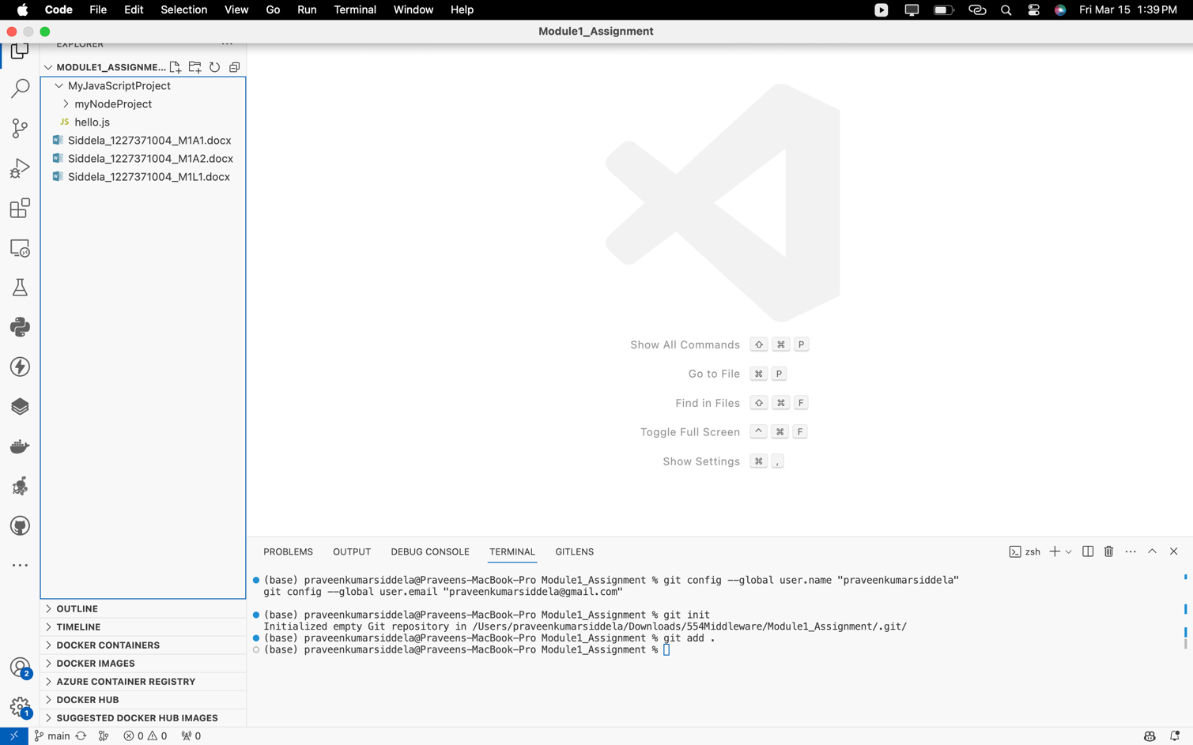

**Screenshot 2 : Module1 Assignment uploaded in GitHub**

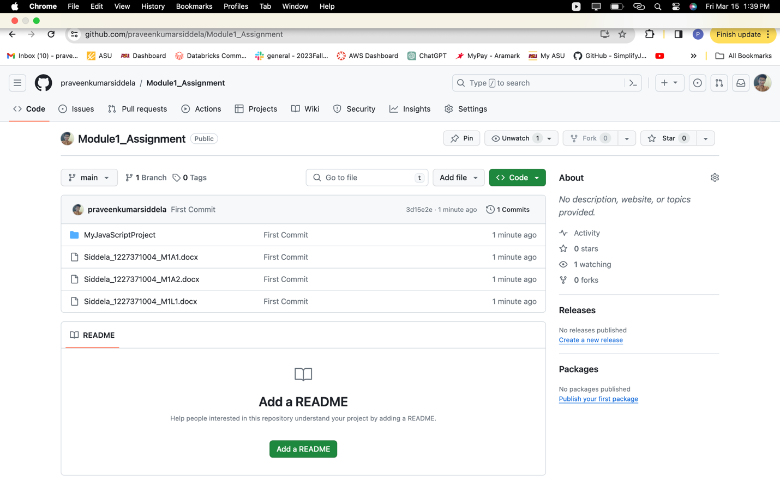

**Screenshot 3 : Module2 Assignment uploaded in GitHub**

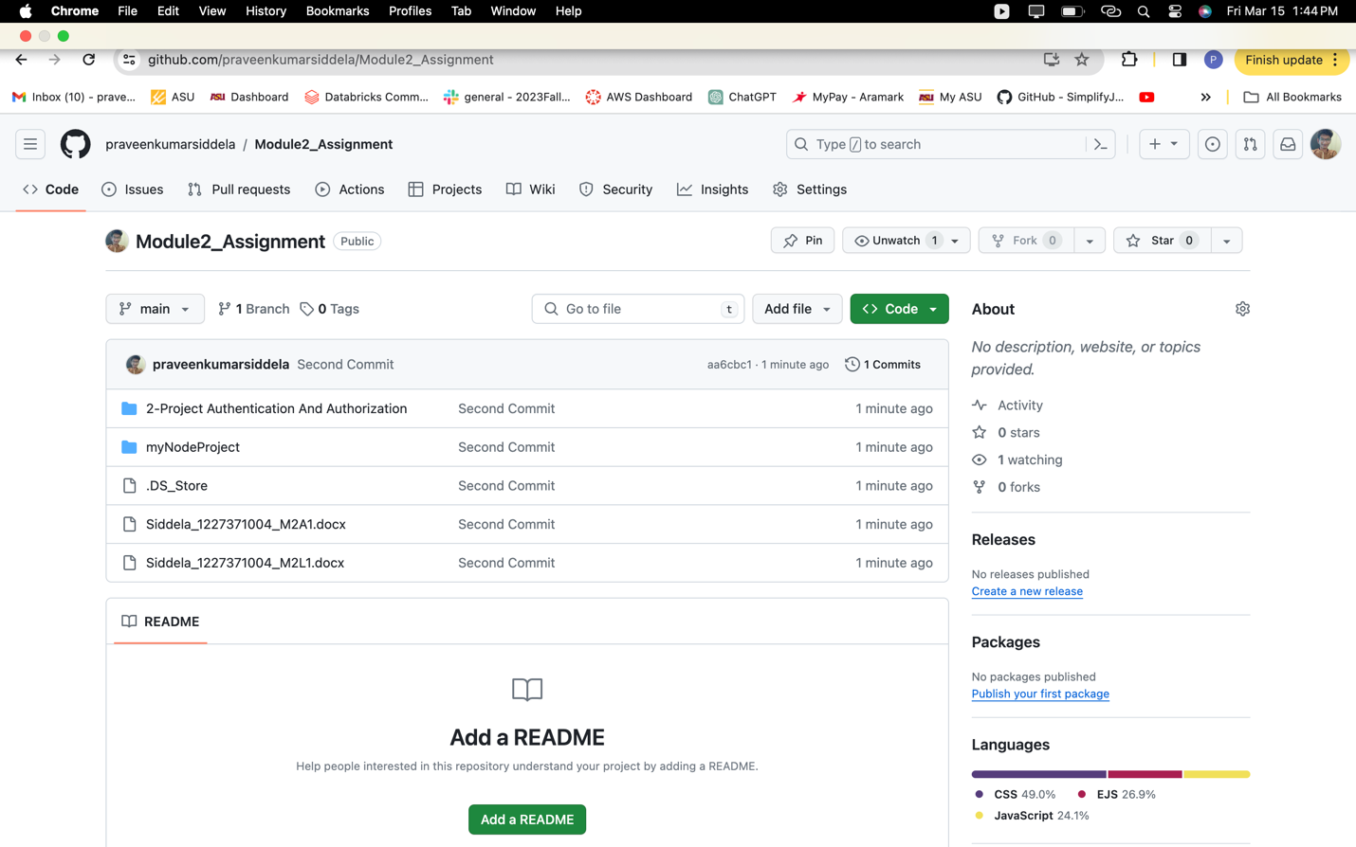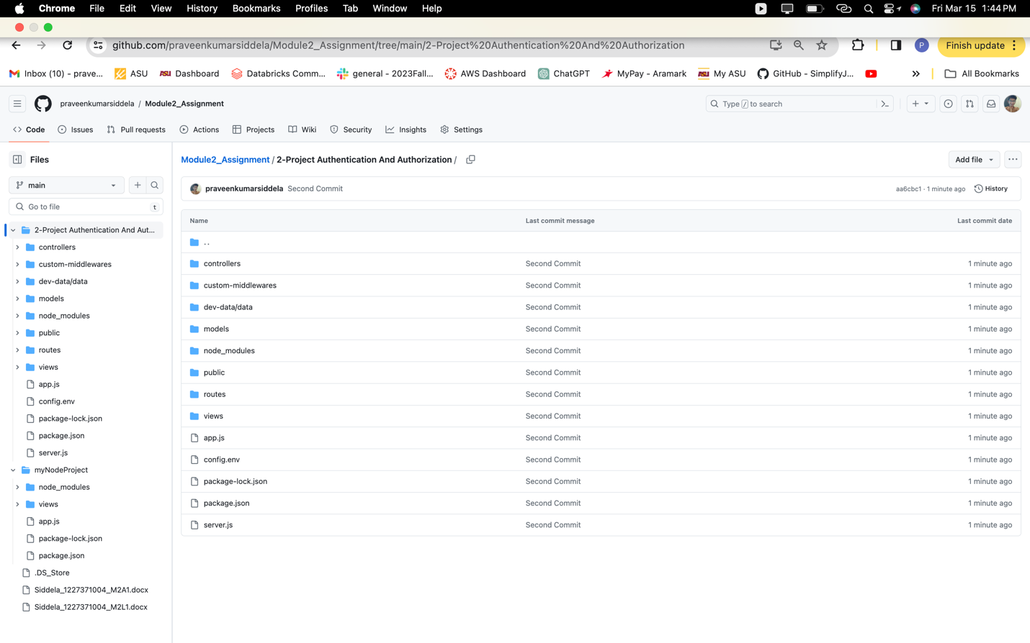

**Screenshot 4: Module3 Assignment uploaded in GitHub**

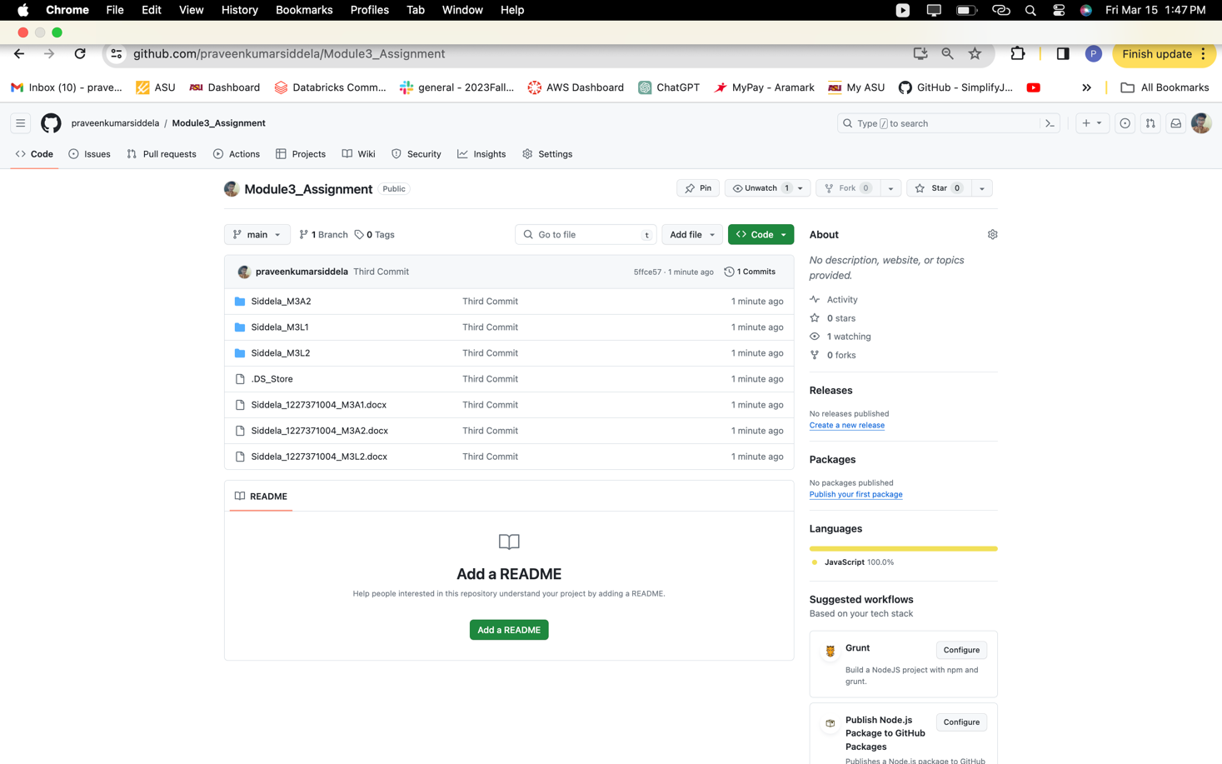

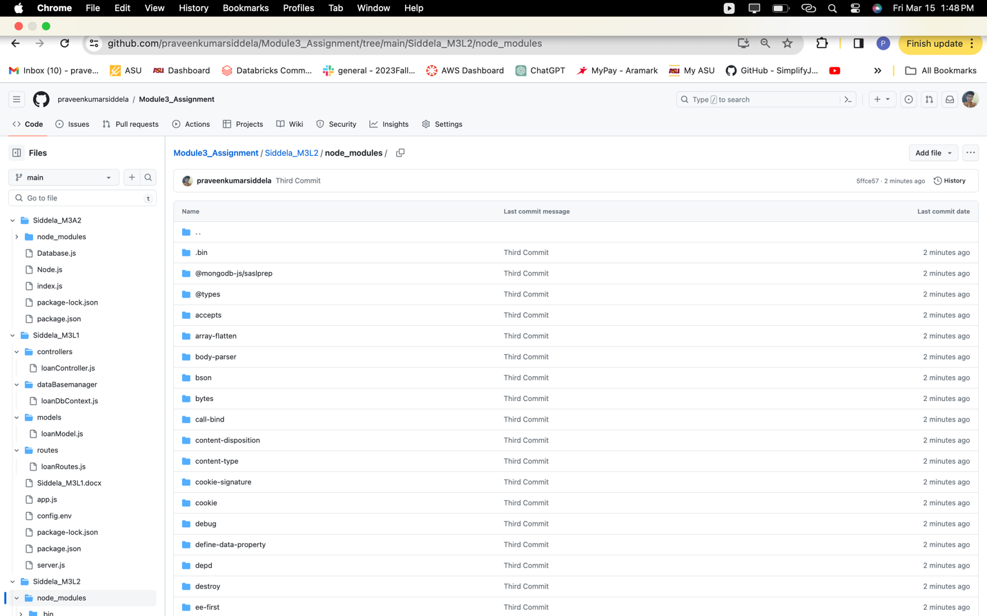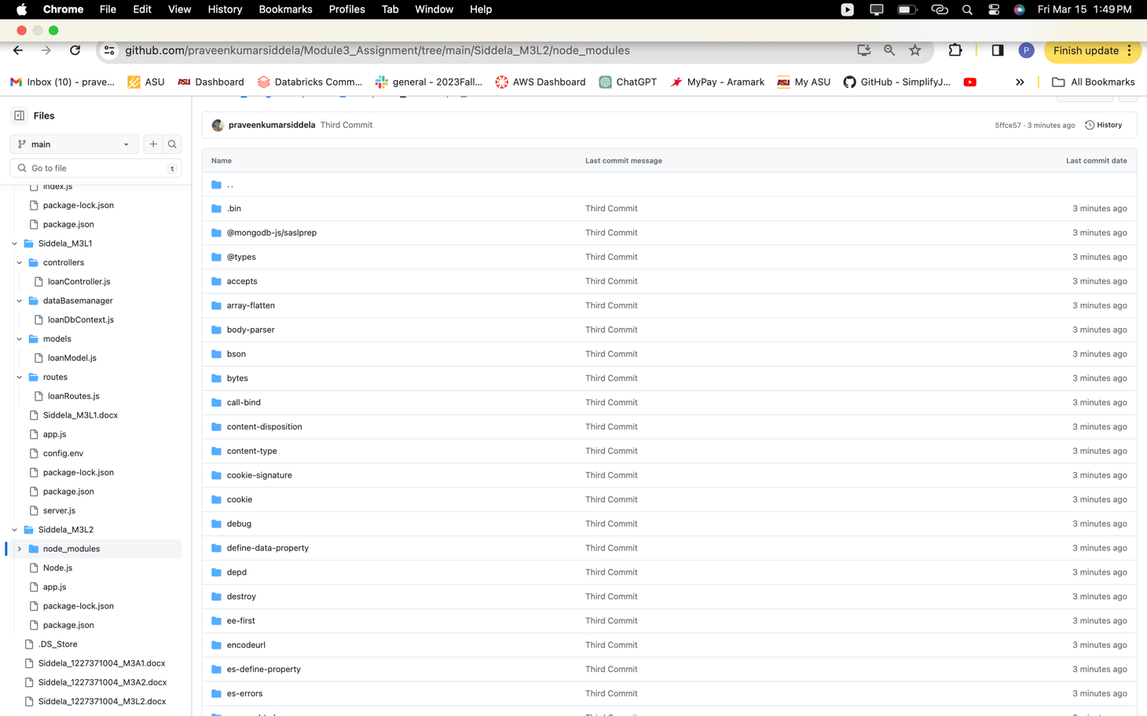

**Screenshot 5 : Module4 Assignment uploaded in GitHub**

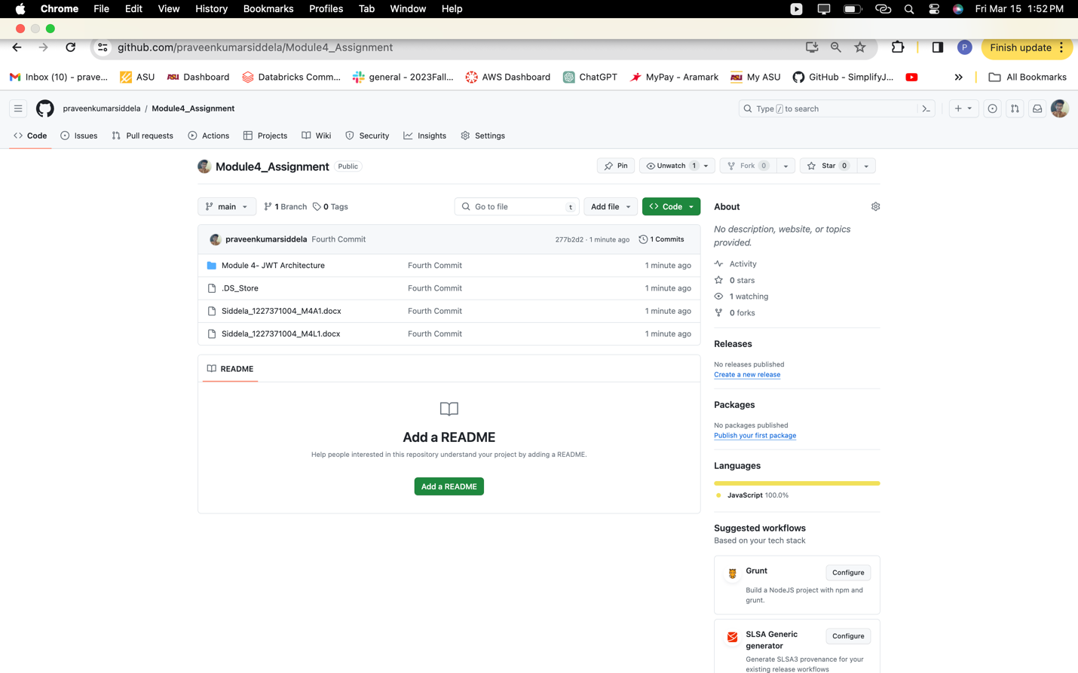

**Screenshot 6 : Module 5 Assignment uploaded in GitHub**

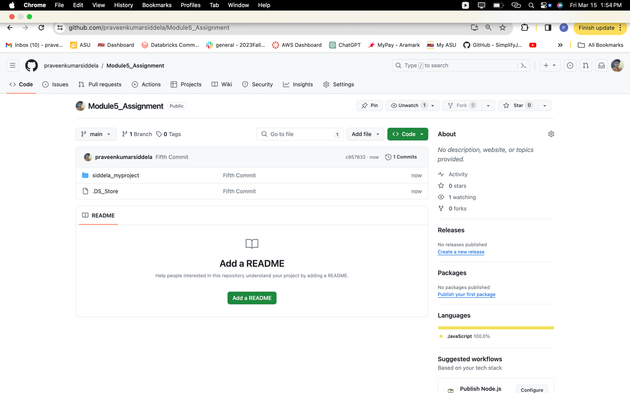

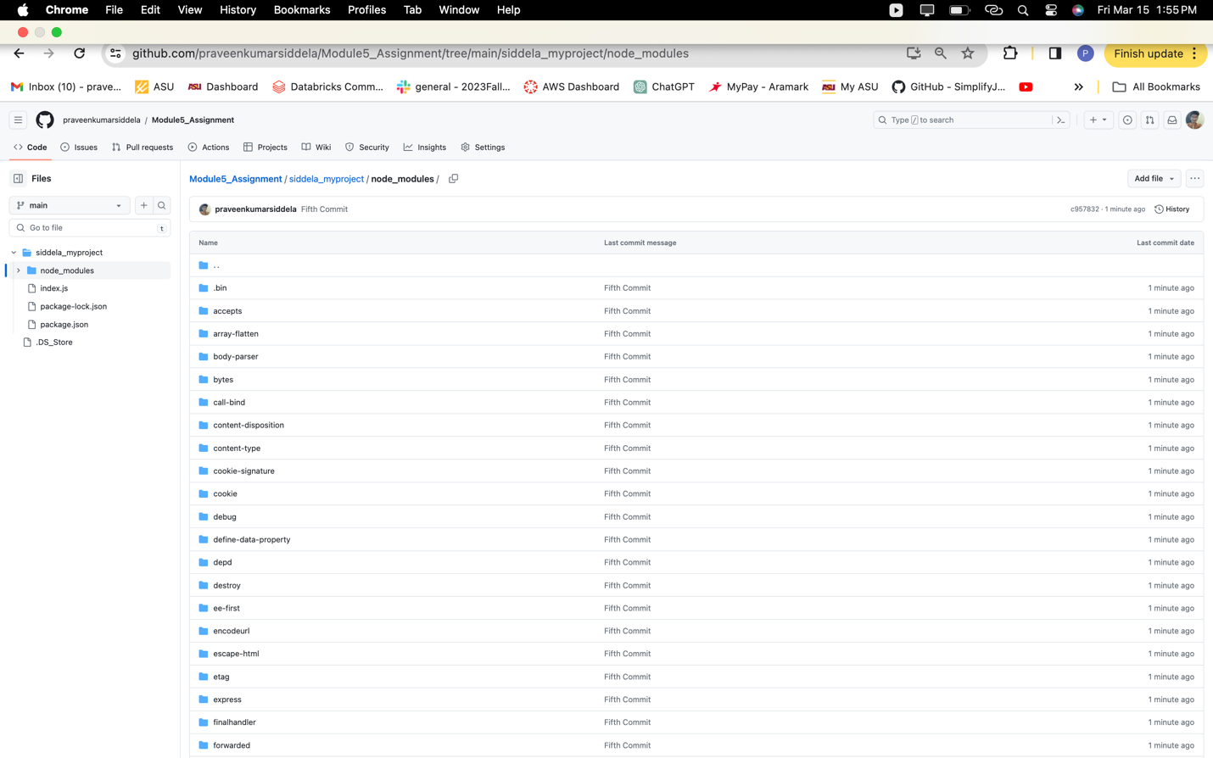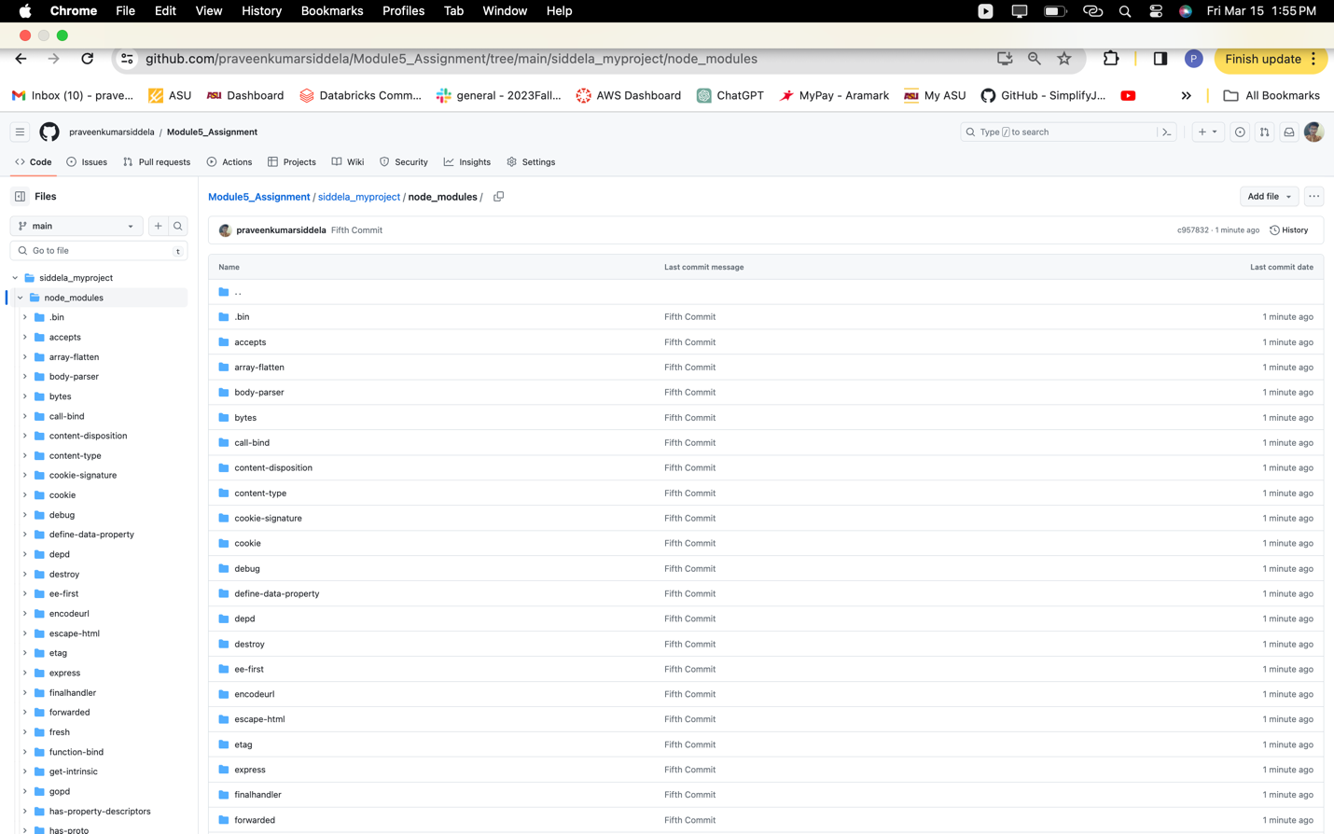

**Screenshot 7 : My Repositories**

